Sadie Barnett-Boudreau                                                                  Saturday, August 15th, 2020

Rice University Data Analytics & Visualization Bootcamp

The VBA of Wallstreet

Multi Year Stock Data Screen Shots

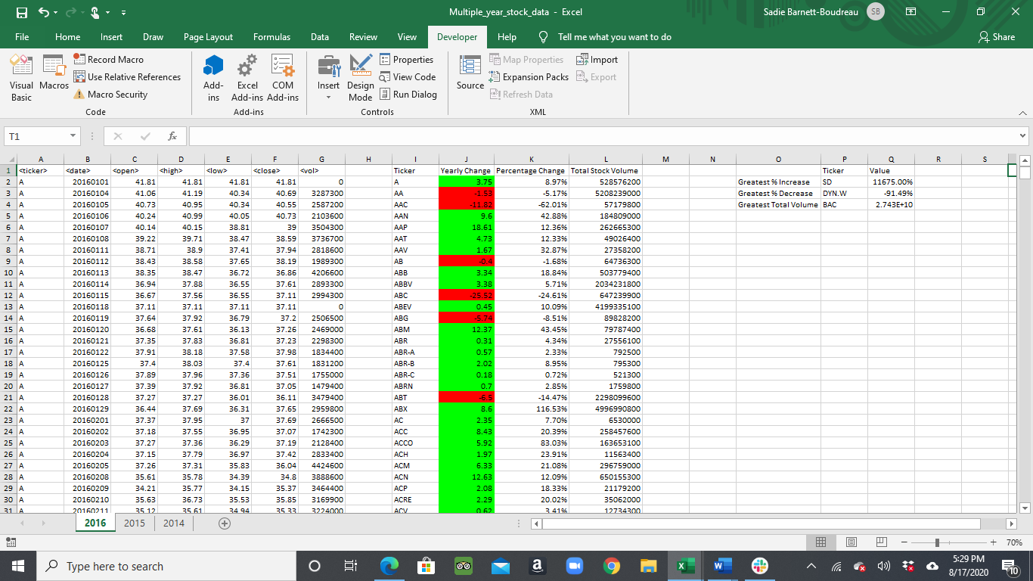**2016**

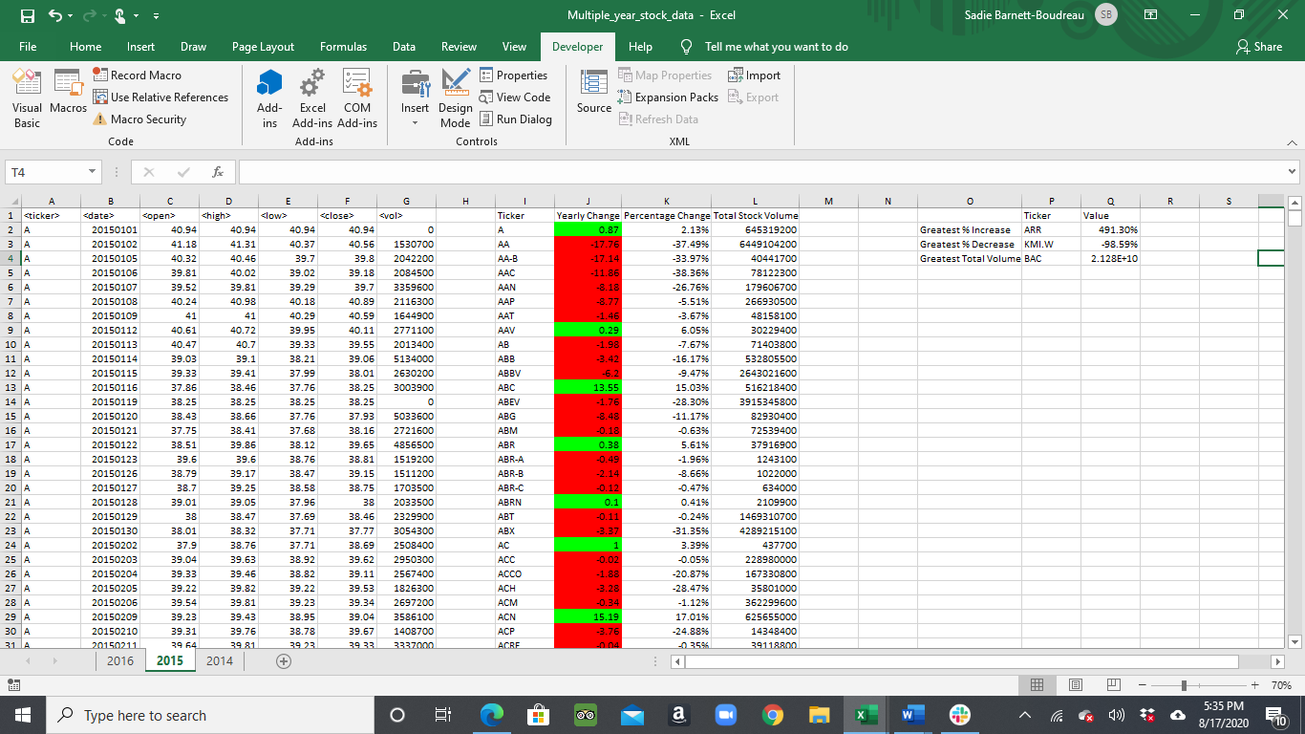**2015**

**2014**

